Lampiran 1
Daftar Perusahaan Pertambangan Batubara
No | Kode | Nama Perusahaan | Kriteria |  |  | Sampel
 |  |  | 1 | 2 | 3
1 | ADRO | Adaro Energy Tbk | ✓ | ✓ | ✓ | 1
2 | ARII | Atlas Resources Tbk | ✓ | ✓ | X | -
3 | ATPK | Bara Jaya Internasional Tbk | ✓ | ✓ | X | -
4 | BORN | Borneo Lumbung Energy & Metal Tbk | ✓ | ✓ | X | -
5 | BSSR | Bamulti Suksessarana Tbk | ✓ | ✓ | ✓ | 2
6 | BUMI | Bumi Resources Tbk | ✓ | ✓ | X | -
7 | BYAN | Bayan Resources Tbk | ✓ | ✓ | X | -
8 | DEWA | Darma Henwa Tbk | ✓ | ✓ | ✓ | 3
9 | DOID | Delta Dunia Makmur Tbk | ✓ | ✓ | X | -
10 | GEMS | Golden Energy Tbk | ✓ | ✓ | ✓ | 4
11 | HRUM | Harum Energy Tbk | ✓ | ✓ | X | -
12 | ITMG | Indo Tambangraya Tbk | ✓ | ✓ | ✓ | 5
13 | KKGI | Resource Alam Indonesia Tbk | ✓ | ✓ | ✓ | 6
14 | MBAP | Mitrabara Adiperdana Tbk | ✓ | ✓ | ✓ | 7
15 | MYOH | Samindo Resources Tbk | ✓ | ✓ | ✓ | 8
16 | PTBA | Tambang Batubara Bukit Asam Tbk | ✓ | ✓ | ✓ | 9
17 | PTRO | Petrosea Tbk | ✓ | ✓ | X | -
18 | SMMT | Golden Eagle Energy Tbk | ✓ | ✓ | X | -
19 | TOBA | Toba Bara SejahteraTbk | ✓ | ✓ | ✓ | 10
20 | FIRE | Alfa Energy Mines Tbk | ✓ | X | X | -
21 | GTBO | Garda Tujuh Buana Tbk | ✓ | X | X | -
22 | PKPK | Perdana Karya Perkasa Tbk | ✓ | X | X | -

Lampiran 2
Lampiran 2 Daftar Return On Equity (ROE) Tahun 2015-2017
Dalam (%)
KODE PERUSAHAAN | 2015 | 2016 | 2017
ADRO | 4.50 | 9.00 | 49.14
BSSR | 25.13 | 21.53 | 21.89
DEWA | 0.21 | 0.24 | 1.22
GEMS | 0.84 | 13.21 | 41.10
ITMG | 7.56 | 14.40 | 26.37
KKGI | 7.39 | 11.22 | 15.17
MBAP | 46.94 | 29.59 | 47.94
MYOH | 26.50 | 19.78 | 12.00
PTBA | 21.93 | 19.18 | 25.70
TOBA | 16.58 | 9.87 | 23.67

Lampiran 3
Daftar Long Term Debt To Equity Ratio (LTDTER) Tahun 2015-2017
Dalam (%)
KODE PERUSAHAAN | 2015 | 2016 | 2017
ADRO | 64.15 | 55.25 | 178.56
BSSR | 24.65 | 20.15 | 25.26
DEWA | 18.10 | 17.92 | 14.67
GEMS | 23.96 | 22.22 | 21.11
ITMG | 11.92 | 13.75 | 26.99
KKGI | 17.93 | 10.12 | 13.78
MBAP | 54.07 | 31.47 | 51.54
MYOH | 37.50 | 18.81 | 13.29
PTBA | 27.82 | 25.41 | 24.45
TOBA | 50.47 | 27.66 | 61.65

Lampiran 4
Debt To Equity Ratio (DER) Tahun 2015-2017
Dalam (%)
KODE PERUSAHAAN | 2015 | 2016 | 2017
ADRO | 78 | 72 | 249
BSSR | 66 | 44 | 40
DEWA | 66 | 69 | 77
GEMS | 49 | 46 | 102
ITMG | 41 | 33 | 42
KKGI | 41 | 22 | 21
MBAP | 116 | 110 | 31
MYOH | 73 | 37 | 33
PTBA | 103 | 76 | 59
TOBA | 130 | 97 | 112

Lampiran 5
Tabel Durbin Watson
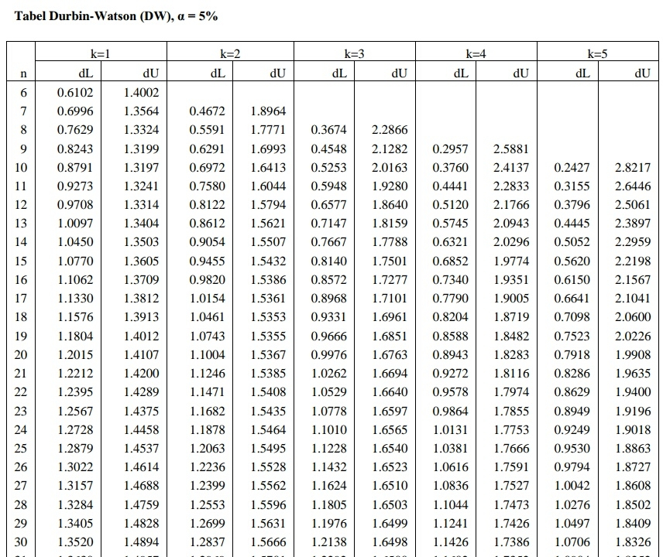

Lampiran 6
Tabel t Probabilitas
Titik Persentase Distribusi t untukProbabilitas= 5%
d.f. | Tingkat Probabilitas
duasisi | 20% | 10% | 5% | 2% | 1% | 0,2% | 0,1%
satusisi | 10% | 5% | 2,5% | 1% | 0,5% | 0,1% | 0,05%
11 | 1,363 | 1,796 | 2,201 | 2,718 | 3,106 | 4,025 | 4,437
12 | 1,356 | 1,782 | 2,179 | 2,681 | 3,055 | 3,930 | 4,318
13 | 1,350 | 1,771 | 2,160 | 2,650 | 3,012 | 3,852 | 4,221
14 | 1,345 | 1,761 | 2,145 | 2,624 | 2,977 | 3,787 | 4,140
15 | 1,341 | 1,753 | 2,131 | 2,602 | 2,947 | 3,733 | 4,073
16 | 1,337 | 1,746 | 2,120 | 2,583 | 2,921 | 3,686 | 4,015
17 | 1,333 | 1,740 | 2,110 | 2,567 | 2,898 | 3,646 | 3,965
18 | 1,330 | 1,734 | 2,101 | 2,552 | 2,878 | 3,610 | 3,922
19 | 1,328 | 1,729 | 2,093 | 2,539 | 2,861 | 3,579 | 3,883
20 | 1,325 | 1,725 | 2,086 | 2,528 | 2,845 | 3,552 | 3,850
21 | 1,323 | 1,721 | 2,080 | 2,518 | 2,831 | 3,527 | 3,819
22 | 1,321 | 1,717 | 2,074 | 2,508 | 2,819 | 3,505 | 3,792
23 | 1,319 | 1,714 | 2,069 | 2,500 | 2,807 | 3,485 | 3,768
24 | 1,318 | 1,711 | 2,064 | 2,492 | 2,797 | 3,467 | 3,745
25 | 1,316 | 1,708 | 2,060 | 2,485 | 2,787 | 3,450 | 3,725
26 | 1,315 | 1,706 | 2,056 | 2,479 | 2,779 | 3,435 | 3,707
27 | 1,314 | 1,703 | 2,052 | 2,473 | 2,771 | 3,421 | 3,690
28 | 1,313 | 1,701 | 2,048 | 2,467 | 2,763 | 3,408 | 3,674
29 | 1,311 | 1,699 | 2,045 | 2,462 | 2,756 | 3,396 | 3,659
30 | 1,310 | 1,697 | 2,042 | 2,457 | 2,750 | 3,385 | 3,646

